Automatic Color Film Tube Packaging Production Line for Electrical Tape
ZRB-500TC+ ZRS-5025POF
Equipment Layout：
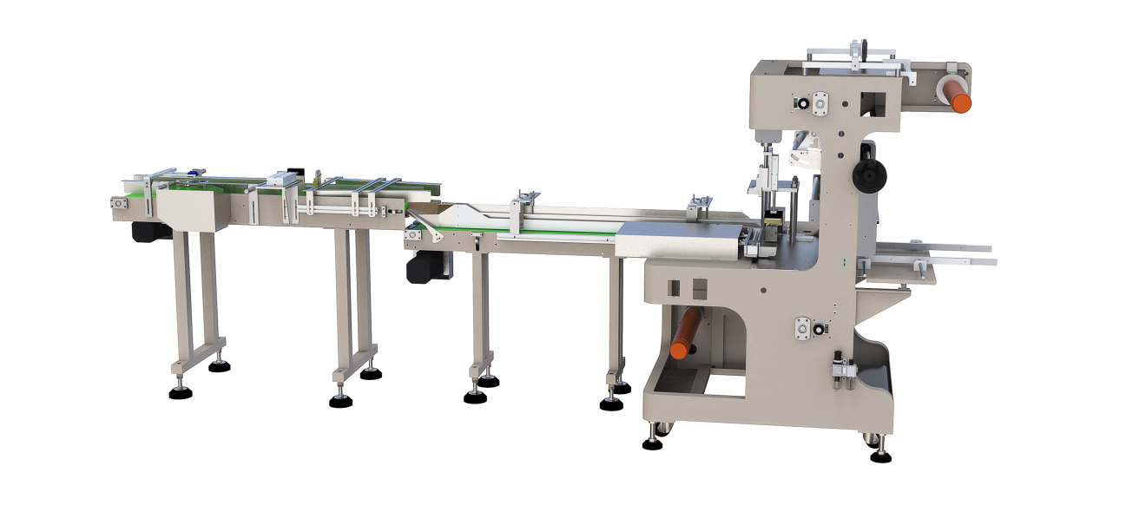
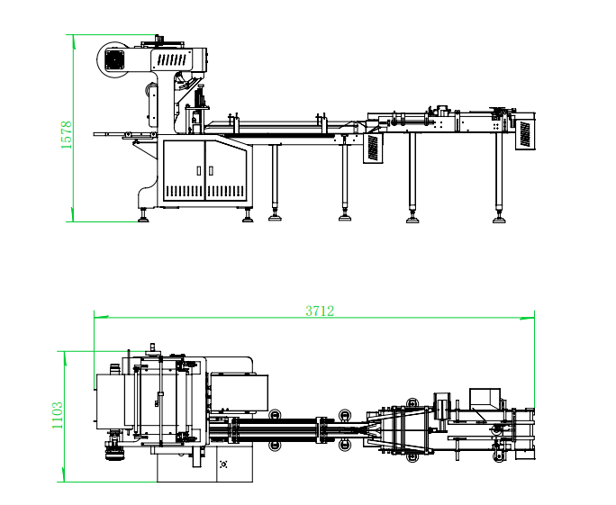
Basic Use：
A production line for full-tube color film packaging, mainly used for packaging electrical tapes in tubes containing 4, 6, 8, or 10 rolls.
Equipment Advantages：
◆ Tape label size adjustable.
◆ Automatic material feeding in two channels，able to package the tapes with marks at both sides with automatic packaging machine.
◆ lmpulse type cold-sealing cutter ensuring smooth edge free from per-heating,which is more convenient to use and emerging saving。Cutting edge of 500mm in effective width.
The patent design，Width and diameter adjustable through a hand wheel with thread，its adjusted to meet the different product whose width is different.
◆ It is applicable to the packaging of both transparent films and color films, with strong practicability.
◆ The whole process is high-speed, unmanned and automatic.

Main Technical Parameters：
Model | Fully Automatic Color Film Tube Wrapping Machine for Electrical Tape  ZRB-500TC | Intelligent Visible Variable-Frequency Heat Shrink Tunnel ZRS-5025POF
Power supply | AC200-240V 50/60HZ 0.6KW | AC380V 50/60HZ 13KW
Packing size | Ø（50-85）mm *H(15-20)mm
Heating furnace dimensions |  | 1500*450*250mm
Packing film | PVC,POF | POF
Packing speed | 10-15/min | 20-40pcs/min
Machine size | 3712(L)*1103(W)*1578(H) | 1800*900*1120mm
Net weight | 330kg | 230KG

Configuration Parameters：
Model | Fully Automatic Color Film Tube Wrapping Machine for Electrical Tape  ZRB-500TC | Intelligent Visible Variable-Frequency Heat Shrink Tunnel ZRS-5025POF
PLC control | Panasonic
Uuivertor |  | cost
touch screen | MCGS
speed motor |  | Zhan peng
air switch | chint | Chint
Switching Mode Power Supply | Mingwei
Three phase asynchronous fan |  | Yunchi
Contactor | Schneider | Chint
Phase failure and phase sequence protector |  | Chint
relay | OMRON | Chint
Servo motor | Shilin
Button switch | Koneda | Heli
Thermostat
Solenoid valve | asicko
Cylinder | Starry sky | Star
electric machinery | Mai Li | Zhan peng
Heating Tube |  | 1.8KW Metal ring
Photoelectric sensor | Yangming
Photoelectric switch | Bojke
Bearing | NSK HRB | HRB
Pneumatic joint |  | China STNC
Insulation layer |  | Made of high-temperature resistant rock wool

